21F-9178

Usman Ali

BCS-6B

Task 1:

HTML:

<!DOCTYPE html>

<html lang="en">

<head>

    <meta charset="UTF-8">

    <meta name="viewport" content="width=device-width, initial-scale=1.0">

    <link rel="stylesheet" href="style.css">

    <title>A1-PartB</title>

</head>

<body style="background-color: blue;">

    <h1>Usman Ali</h1>

    <h2>21F-9178</h2>

    <p>Iam Usman currently in 6th semester of my bachelors in Computer Science</p>

    <style>

        h1{

            font-size: 36px;

        }

    </style>

</body>

</html>

CSS:

*{

    box-shadow: 2px 2px 3px 1px rgba(0, 0, 0, 0.2);

}

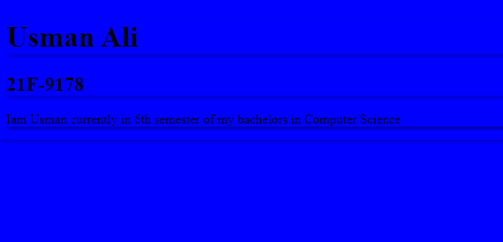

Task2:

HTML:

<!DOCTYPE html>

<html lang="en">

<head>

    <meta charset="UTF-8">

    <meta name="viewport" content="width=device-width, initial-scale=1.0">

    <link rel="stylesheet" href="style.css">

    <title>A1-PartB</title>

</head>

<body>

    <h2>Start CSS Exercise</h2>

    <p>Good luck!</p>

    <button>Start CSS Exercise ></button>

</body>

</html>

CSS:

body{

    background-color: rgb(58, 51, 51);

}

h2{

    color: white;

}

p{

    color: white;

}

button{

    color: white;

    background-color: rgb(23, 160, 103);

    height: 50px;

    width:220px;

    border-radius: 10px;

}

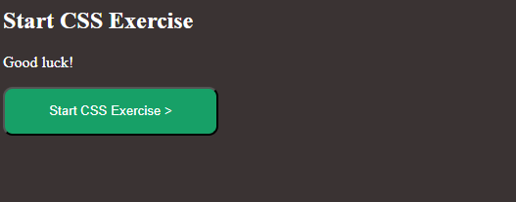

Task 3:

Html:

<!DOCTYPE html>

<html lang="en">

<head>

    <meta charset="UTF-8">

    <meta name="viewport" content="width=device-width, initial-scale=1.0">

    <link rel="stylesheet" href="style.css">

    <title>A1-PartB</title>

</head>

<body>

    <div class="form1">

        <h1>Contact Us</h1>

        <div class="form-content">

            <form action="">

                <label for="name">Your Name</label>

                <input type="text" placeholder="Usman Ali">

                <label for="email">Your Email</label>

                <input type="email" placeholder="Usman@example.com">

                <label for="phone">Your Phone Number</label>

                <input type="text" placeholder="Format: 123-456-789">

                <label for="message">Your Message</label>

                <textarea name="" id="" cols="30" rows="10" placeholder="Type your message here..."></textarea>

                <input type="submit">

                <input type="reset">

            </form>

        </div>

    </div>

</body>

</html>

CSS:

form{

    box-shadow: 2px 2px 2px 2px rgba(0, 0, 0, 0.2);

}

.form1{

    text-align: center;

}

.form-content form{

    display: flex;

    align-items: center;

    justify-content: center;

    flex-direction: column;

}

.form-content input{

    width: 220px;

    margin: 10px;

}

.form-content input[type="submit"]{

    color: white;

    background-color: rgb(50, 155, 50);

    height: 35px;

}

.form-content input[type="reset"]{

    color: white;

    background-color: rgb(50, 155, 50);

    height: 35px;

}

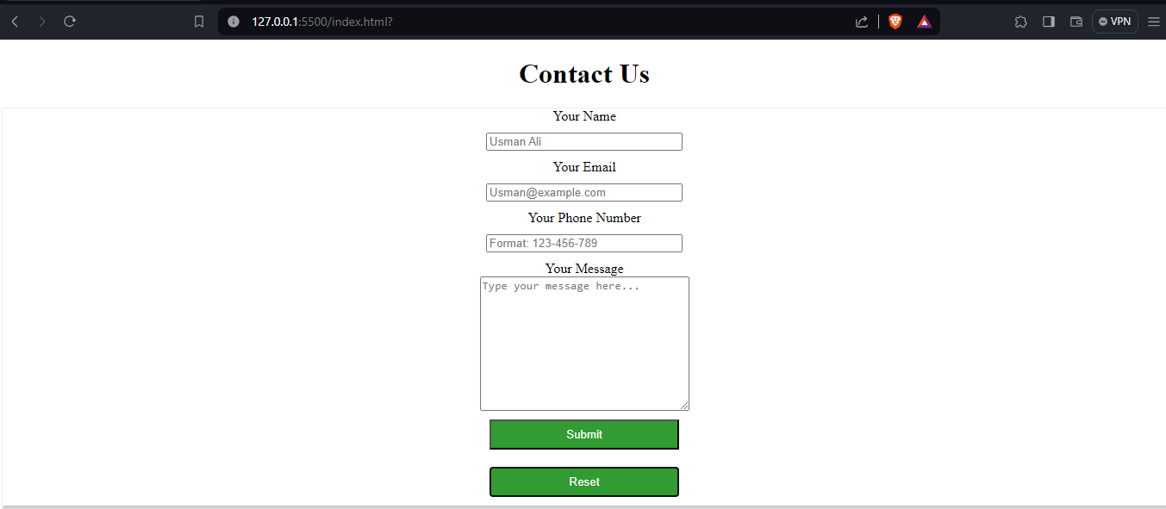

Task 4:

HTML:

<!DOCTYPE html>

<html lang="en">

<head>

    <meta charset="UTF-8">

    <meta name="viewport" content="width=device-width, initial-scale=1.0">

    <link rel="stylesheet" href="style.css">

    <title>A1-PartB</title>

</head>

<body>

    <div class="card">

        <div class="cardimage">

            <img src="/landscape.png" alt="">

        </div>

        <div class="card-text">

            <p>Demo Text</p>

        </div>

    </div>

</body>

</html>

CSS:

.cardimage img{

    height: 250px;

    width: 250px;

}

.card{

    border: 1px solid #ccc;

    border-radius: 8px;

    box-shadow: 0 4px 8px rgba(0, 0, 0, 0.1);

    padding: 20px;

    margin: 20px;

    width: 250px;

    background-color: #fff;

}

.card-text{

    padding: 10px;

}

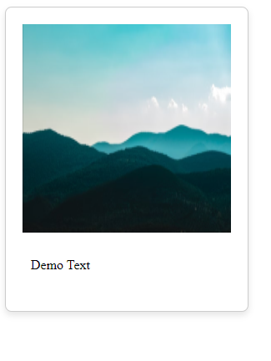

Task 5:

HTML:

<!DOCTYPE html>

<html lang="en">

<head>

    <meta charset="UTF-8">

    <meta name="viewport" content="width=device-width, initial-scale=1.0">

    <link rel="stylesheet" href="style.css">

    <title>A1-PartB</title>

</head>

<body>

    <div class="navbar">

        <div class="nav-txt">

            <h2>Usman Ali</h2>

            <h4>Student</h4>

        </div>

        <div class="nav-img">

            <img src="images/my-removebg-preview.png" alt="">

        </div>

    </div>

    <div class="nav-links">

        <img src="images/LinkedIn_icon_circle.svg-removebg-preview.png" alt="">

        <a href="https://www.linkedin.com/in/muhammad-usman-ali-294701242/" target="_blank">Linkedin</a>

        <img src="images/Gmail-logo.png" alt="">

        <a href="mailto:usmanmanagement23@gmail.com">usman@gmail.com</a>

        <img src="images/github.png" alt="">

        <a href="https://github.com/UsmanAli90" target="_blank">Github</a>

    </div>

    <div class="aboutme all">

        <h2>About me</h2>

        <p>Lorem ipsum dolor sit amet consectetur adipisicing elit. Distinctio, voluptatibus.</p>

    </div>

    <div class="personal-info all">

        <h2>Personal Information</h2>

        <div class="info">

            <li> <span> Date of birth: </span> Jan 1,1990</li>

            <li><span> Nationality: </span> Pakistani</li>

            <li><span> Address: </span> Your Address</li>

            <li> <span> Email: </span> Dummy@gmail.com</li>

            <li><span> Phone: </span> 123-456-789</li>

        </div>

    </div>

    <div class="education all">

        <h2>Education</h2>

        <li><span>Degree: </span>BSCS</li>

        <li><span>Institution: </span>FAST</li>

        <li><span>Gard Year: </span>2025</li>

    </div>

    <div class="work all">

        <h2>Work Experience</h2>

        <li><span>Job Title: </span>None</li>

        <li><span>Company: </span>None</li>

        <li><span>Duration: </span>None</li>

        <li><span>Responsibilities: </span>None</li>

    </div>

    <div class="projects">

        <h2>My Projects</h2>

        <div class="proj1">

            <h3>Project 1</h3>

            <p>Lorem ipsum dolor sit amet consectetur adipisicing elit. Enim, ipsum sint eius non ipsa tempore tenetur

                aliquid dolore ullam, aperiam illum, cumque distinctio! Itaque consequuntur blanditiis, nihil aliquid

                minima quia maxime id qui debitis soluta quasi ea officia ratione accusantium facilis libero illum

                molestias at!</p>

            <button>View Details</button>

        </div>

        <div class="proj2">

            <h3>Project 2</h3>

            <p>Lorem ipsum dolor sit amet consectetur adipisicing elit. Enim, ipsum sint eius non ipsa tempore tenetur

                aliquid dolore ullam, aperiam illum, cumque distinctio! Itaque consequuntur blanditiis, nihil aliquid

                minima quia maxime id qui debitis soluta quasi ea officia ratione accusantium facilis libero illum

                molestias at!</p>

            <button>View Details</button>

        </div>

    </div>

    <div class="skills all">

        <h2>My Skills</h2>

        <li>HTML</li>

        <li>CSS</li>

        <li>JS</li>

    </div>

    <div class="footer">

        <p>Contact me at usman@gmail.com</p>

    </div>

</body>

</html>

CSS:

*{

    margin: 0;

    padding: 0;

}

.navbar{

    color: white;

    display: flex;

    align-items: center;

    justify-content: center;

    background-color: rgb(113, 113, 172);

    height: 140px;

}

.nav-txt h2,h4{

    text-align: center;

    padding-top: 14px;

}

.nav-img img{

    height: 100px;

}

.nav-txt h2{

    font-size: 30px;

}

.nav-links{

    background-color: rgb(113, 113, 172);

    text-align: center;

}

.nav-links a{

    color: white;

    padding: 10px;

    text-decoration: none;

}

.nav-links img{

    width: 20px;

}

.nav-links a:hover{

    font-style:italic;

}

.all{

    height: 130px;

    margin: 20px;

    margin-top: 70px;

    box-shadow: 2px 2px 2px 2px rgba(0, 0, 0, 0.5);

    padding: 20px;

}

/* .all:hover{

    margin-top: 40px;

} */

.all span{

    font-weight: bold;

}

.projects{

    margin: 20px;

    margin-top: 90px;

    box-shadow: 2px 2px 2px 2px rgba(0, 0, 0, 0.5);

    padding: 20px;

}

.proj1{

    padding-top: 20px;

}

.proj2{

    padding-top: 40px;

}

.projects button{

    color: white;

    margin-top: 10px;

    height: 30px;

    width: 100px;

    background-color: rgb(72, 72, 197);

}

.projects button:hover{

    cursor: pointer;

    background-color: rgb(39, 39, 153);

}

.footer{

    margin-top: 50px;

    background-color: rgb(113, 113, 172);

    height: 80px;

}

.footer p{

    color: white;

    font-size: 20px;

    text-align: center;

    padding-top: 25px;

}

